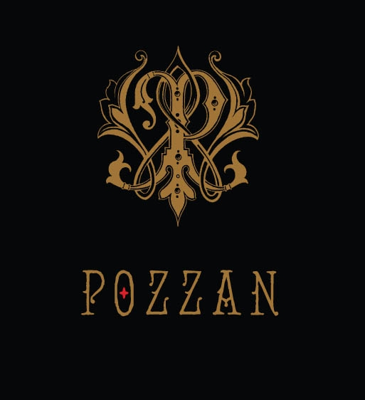

Pozzan
2011~Zinfandel

Technical Analysis:
Varietal Zinfandel (100%)
Appellation Oakville, Napa Valley
Alcohol 14.1%
Aging 18 Months in French and American Oak
Production 300 cases

Tasting Notes:
Medium plum color with aromas of dried raspberry and wild blackberry, french oak vanilla and black pepper spice notes. The palate is refined with expressive and concentrated old vine character, supple and concentrated from the first sip with a rich, sappy core of cinnamon and black cherry notes - then turn to ripe plum with interesting dried fruit quality, reminiscent of a fine Amarone. The finish is balanced in its concentration with ripe plum, cherry essence and pomegranate and replete with exotic spices like clove, sandalwood, cinnamon and allspice.

This fine Napa Zinfandel pairs well with slow cooked meats such dry rubbed pork loin, served with parsnip mashed potatoes and pickled beets.

